**Installation Guide**

**Requirement：**

**OS: win10, win7 or win8**

**Browser: chrome 88, IE 11, or later versions**

1. **Installation**

Downloads installer (MsgEncryptionKit.SGE.exe) from SGE website (<https://en.sge.com.cn/membership_downloads> or click menu: Membership -> Downloads -> Membership), right-click installer and run as administrator.(note: close your IE browser and chrome browser before install.)

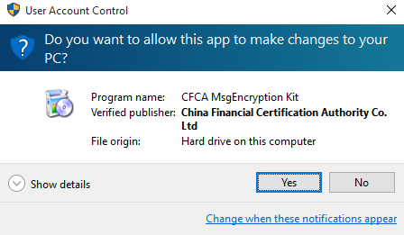

* If you run installer with browsers on, there will be an alert which says “Please close Chrome then retry”. Please click “Yes” and continue. For an example:

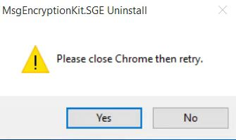

* If you install security plugin successfully, window below will be opened：

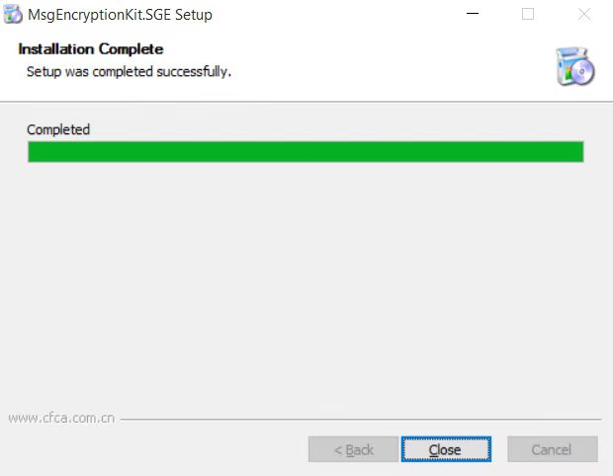

1. **Environment Check**

## OS environment Check

* If you successfully install security plugin, please check as below:

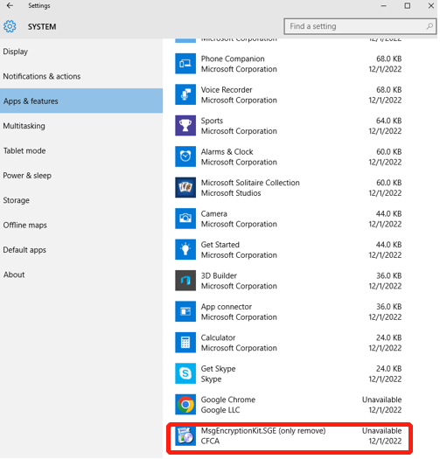

## Chrome Extension Check

* Chrome extension check

Please open chrome first, link to “chrome://extensions”, then check if “CFCA MessageEncryption.SGE Extension” is in your extensions with open state.

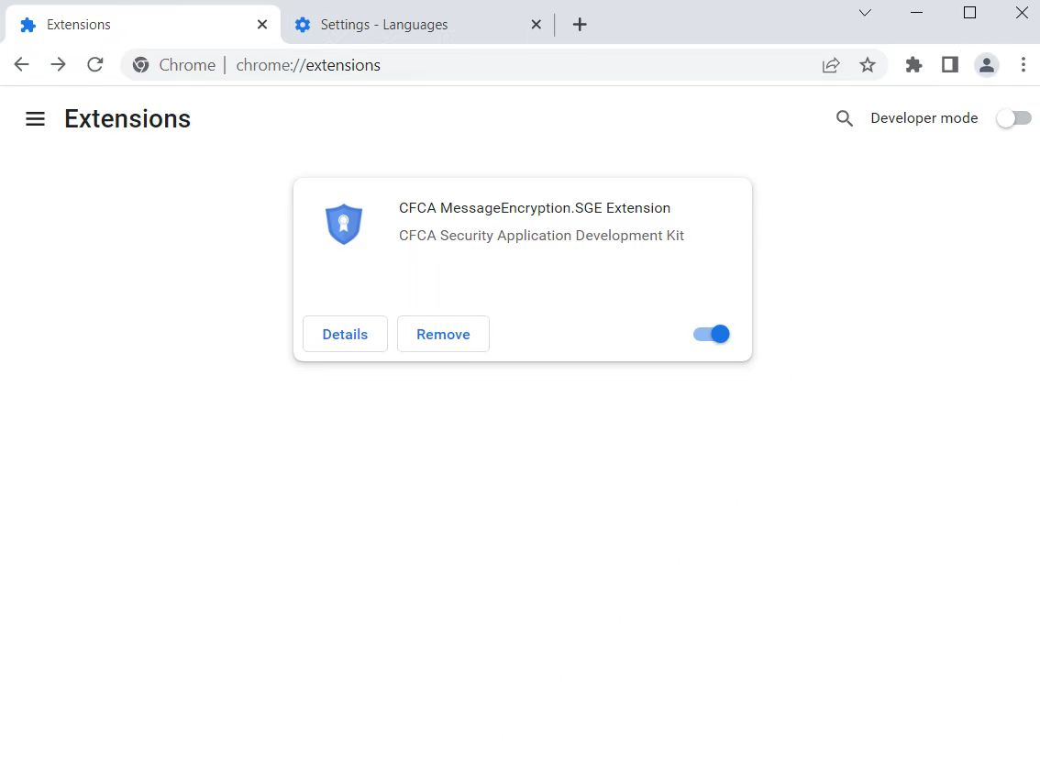

Note: If there is no “CFCA MessageEncryption.SGE Extension” at the Chrome Extensions page, then switch to the Developer Mode and refresh Chrome Extensions page, drag the crx file below(or use e-mail attachment) to Chrome Extensions page,. The crx file:

